SCORE MyCourses – A Course Scheduling System
Team members: Will Crawford, Sabba Petri, Eric Stegall, Justin Lazaro, Benjamin Ross

Design

Change Record:
Date | Version | Chages/Additions | Responsible Person

Table of Contents:

- Overview
- Architecture Diagram
- Class Diagrams
- UML Interaction Diagrams

Overview:
This document is designed to provide an overview of the design of our S.C.O.R.E. Scheduling based on our requirement documents. Included in this document are the architecture diagram, UML structure, interaction diagrams, and class diagrams. Each of the diagrams contains the structure and interaction pertaining to each level of authentication.

Architecture Diagram:
The architecture of the S.C.O.R.E. Scheduling system consists of a users, web portal, and designated server. All users will access their portal through a web browser to interact with the underlying server. Inside of the server, Django will be handling all incoming and outgoing HTTP requests between the users, the algorithm and the database. Based on the credentials of the user, Django will decide which page to return and which interface to provide. If the program manager or program administrator needs to have a populated table, Django will query the database to get the information requested specific to that user. Then Django will populate the HTML page with the correct information and return the dynamic page to the user. The database will contain numerous tables including: course catalog, room catalog, and user groups. If a request is made by the admin to create the schedule, Django will use the necessary course files for the algorithm to run. These files are the course information and room information. Based on the output of the algorithm, Django will fill the seperate database table with the new schedule, from which the users can view and sign up for classes (in the case of students).
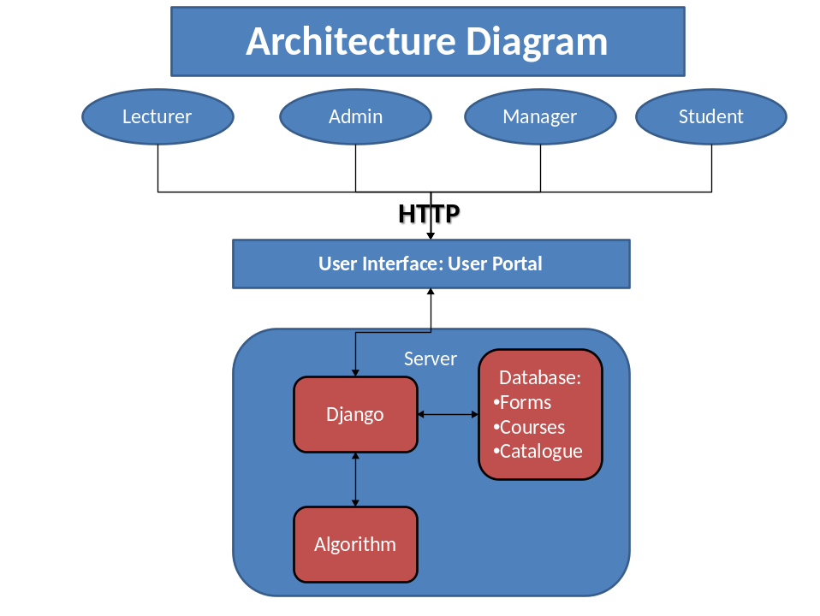
Figure 1: System Architecture
Algorithm Architecture:
The algorithm architecture is described as follows: after Django populates the class (lectures) files and the room files, the algorithm starts to create the room tables. These room tables are filled based on the fitness of a class in a certain room at a certain time. The fitness is the product of such variables as difference in class size to room size, time preference and lecture preference. More variables can be added as the database becomes more complex. After the room tables have been created, the master schedule is created. All of the room tables are compared and each class is scheduled in a specific room at a certain time. Once the master table is created, the master table files will be returned to Django and the database will be changed. 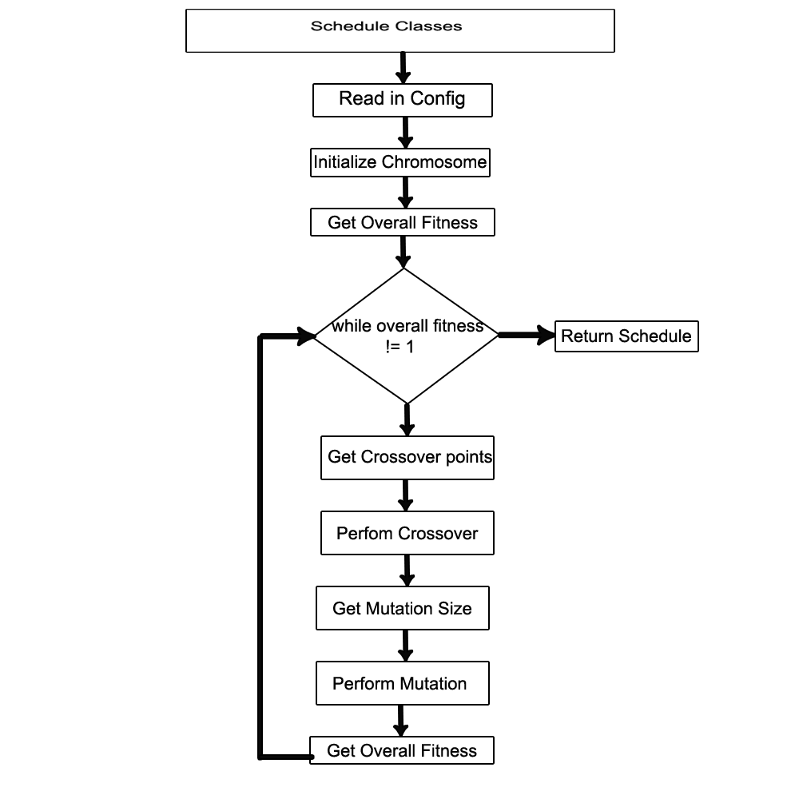
Figure 2: Algorithm Architecture

Class Diagrams:
The class diagram in figure 3 is a picture of our algorithm that will be the heart and engine of our Scheduling system. This class diagram shows the relationship between the configuration python file with the different database attributes such as professor, course, room, schedule, and course class. The configuration class is the primary driver that weaves all the user groups and database attributes together to function as a single entity. 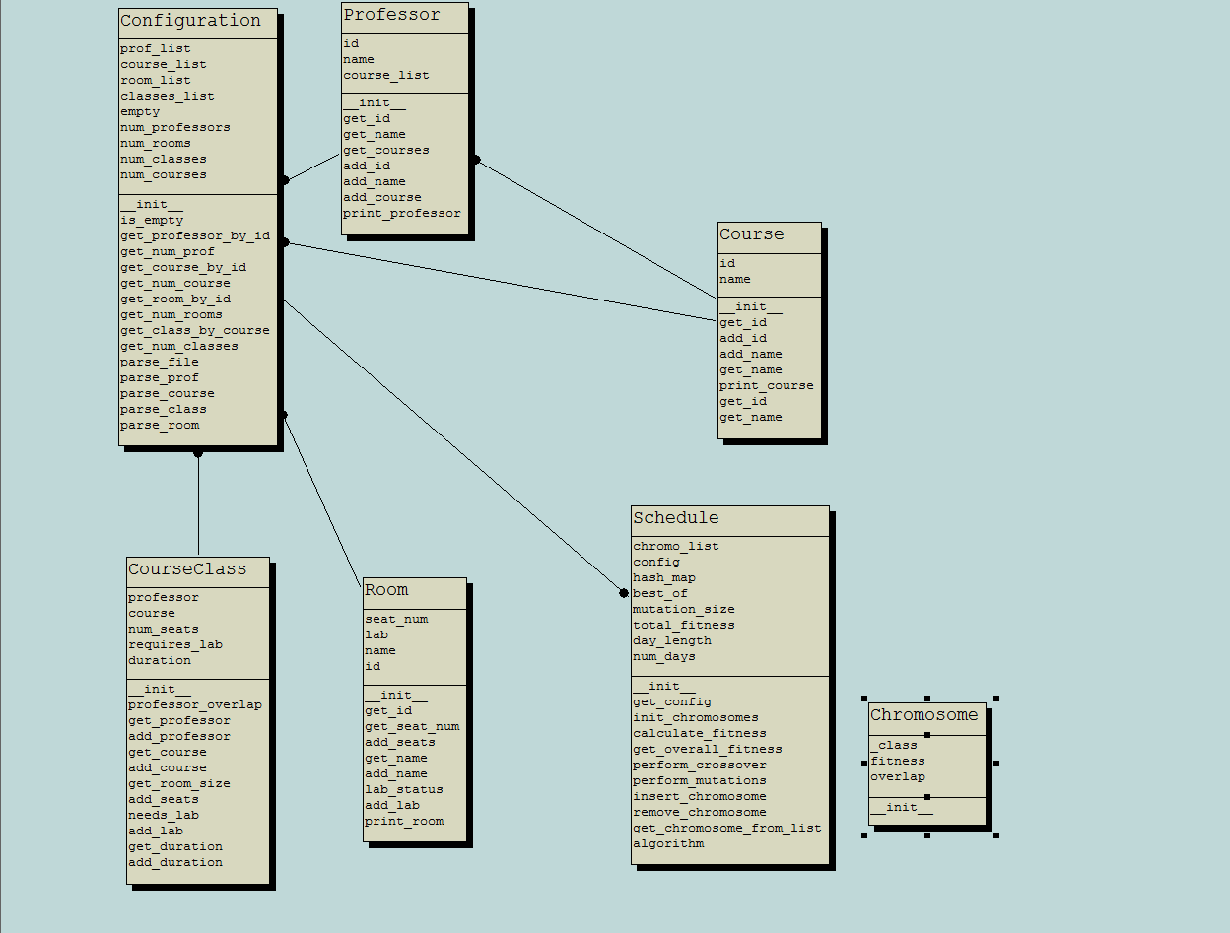
Figure 3: Class diagram of Algorithm
Major Design Decisions:
There are two major design decisions made in this system: the web server technology and the algorithm to schedule the classes.
- Web Server: Django was picked because of its ability to ease the creation of database-driven websites. It provides an abstracted framework for dynamic websites that is easy to learn and easy to integrate. It is primarily written in Python, which is the language of choice for this project. Django's available components will also help us through all design phases.
- Algorithm: The two options for the algorithm was to either go with a constraint based solver, or design an algorithm in house to do the job. The scheduling problem is an NP-Hard problem, meaning that no “fast” optimal solution exists. Using a constraint based solver would ease the programming end of the algorithm team; however, learning to use a constraint based solver would require more time to learn. Designing an algorithm in house was picked due to its ease of integration with the web server framework, and its simplicity. The design of the algorithm also allows the admin to change the schedule as they see fit.

Interaction Diagram:
The interaction diagrams are modeled each after the scenarios from our scenarios document. The interaction diagrams contains each interaction of all users: students, lecturers, program managers, and program administrators. Each diagram details and provides a pictorial representation of the user’s interaction with the system such as the HTML website, the django engine, the database, and the algorithm. In all these diagrams, the HTML portal (website) is an input/output object wherein users will input items and receive output from django. Django is a control object that controls all aspect of user, database, and algorithm interactions. The database is an entity that that stores information from user input that is processed by django, it also provides output to the user. Finally, the algorithm is a control entity that manipulates the database courses, but all functionality of the algorithm is hidden from the entire system.
Student
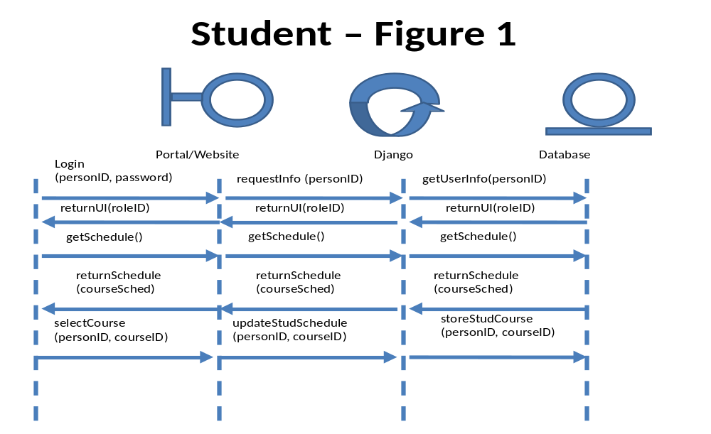
Figure 3.1: Student interaction diagram
- The student will login with their ID and password on the portal. Django will read the ID and password and match it with the database.
- Once the database confirms user, the database will return the correct UI for the student.
- The student will want to get the schedule of classes to sign up for and “makes a request” to django and the database to display the available courses. By “makes a request” this is done invisible to the user, the user will simply click on the courses tab and this will automatically do it for the user.
- The student can now select courses and store them into their profile on the database.
Program Administrator
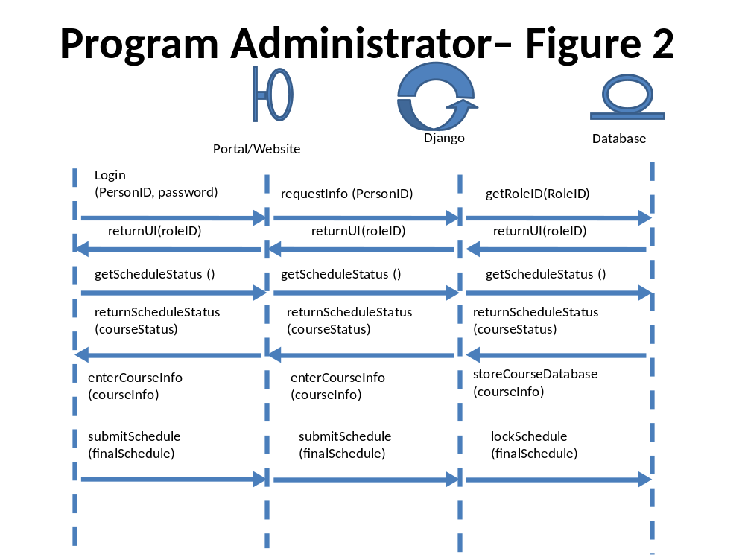
Figure 3.2: Program Admin enters courses interaction diagram
- The program administrator will login with their ID and password on the portal. Django will read the ID and password and match it with the database.
- Once the database confirms user, the database will return the correct UI for the program administrator.
- The program administrator will want to know the status of the schedule to see if it is finished or not, it will make a request to django and the database to find out the status.
- The database will return the status.
- The program administrator will begin filling out course information through a courseInfo object that will contain various data about a given course.
- When the program administrator feels done, they can choose to submit the course and lock the course in the database.
Program Administrator
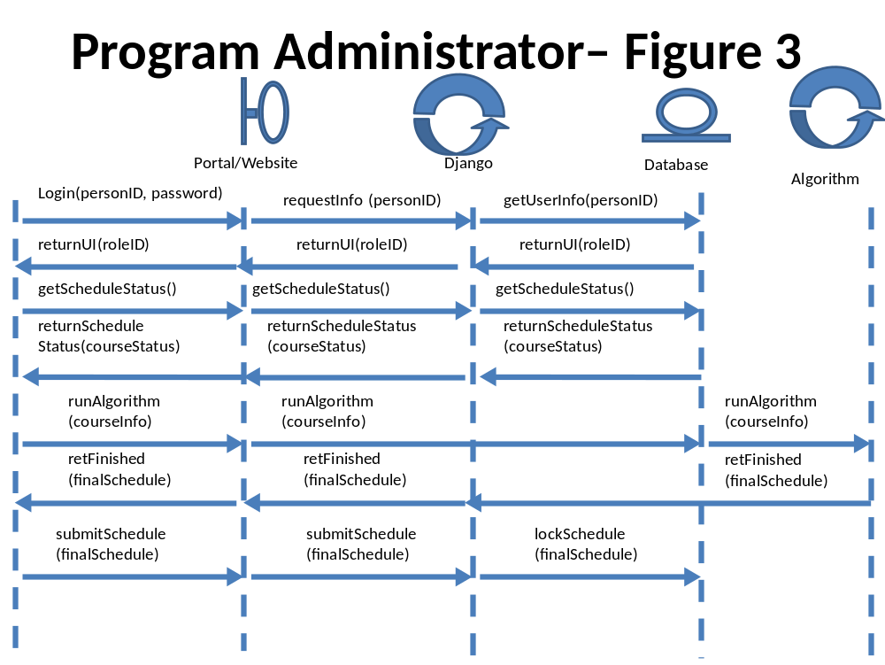
Figure 3.3: Program Administrator runs algorithm interaction diagram
- The program administrator will login with their ID and password on the portal. Django will read the ID and password and match it with the database.
- Once the database confirms user, the database will return the correct UI for the program administrator.
- The program administrator will want to know the status of the schedule to see if it is finished or not, it will make a request to django and the database to find out the status.
- The database will return the status to see if the program manager has completed the schedule.
- If the schedule is complete, the program administrator will run the algorithm that will be passed through Django and straight into the algorithm engine.
- When the engine has completed, it will return a message that it is complete to the HTML website.
- Once the program administrator reviews the schedule, the program administrator can submit and lock the schedule and provide it to students
Lecturers
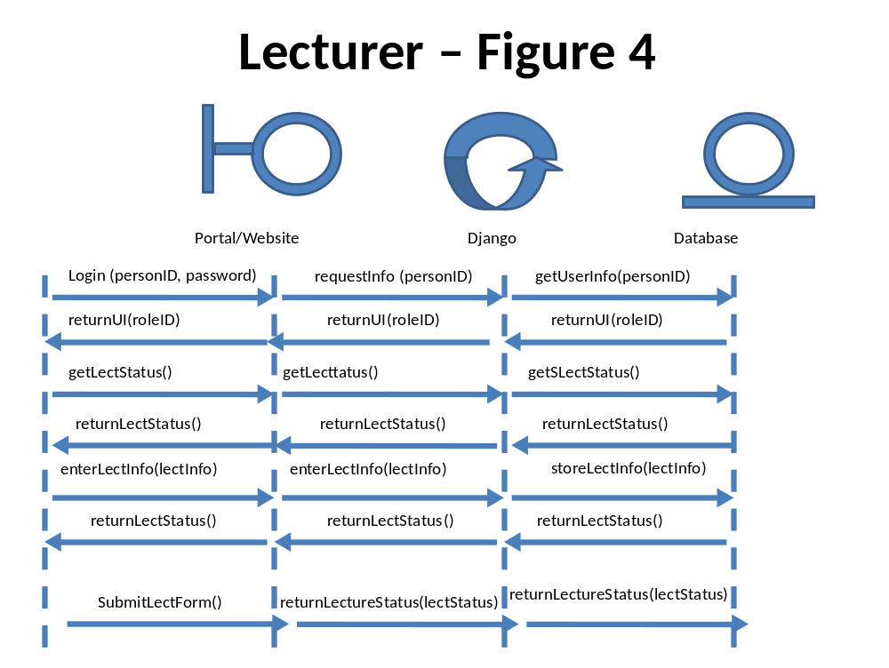
Figure 4: Lecturer interaction diagram
- The lecturer will login with their ID and password on the portal. Django will read the ID and password and match it with the database.
- Once the database confirms user, the database will return the correct UI for the lecturer.
- The lecturer will want to find out if the lecturer has completed his constraint form. So upon logging in, django will send a message on the status of his constraint form based on a status in the database.
- The lecturer will fill out the constraint forms and store it in the database.
- Upon storing it in the database, the lecture status will be updated and confirmed.
- The lecturer can now formally submit his constraints form to the database.
Program Manger
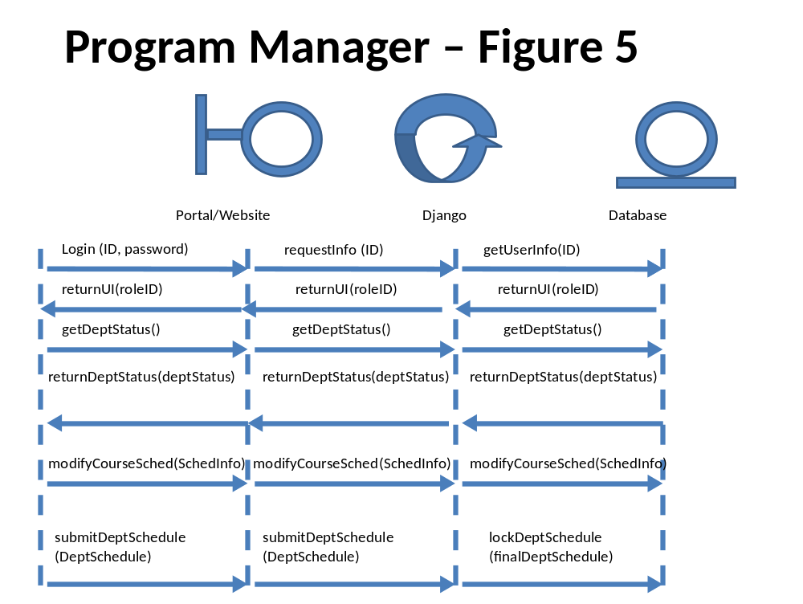
Figure 5: Program Manager interaction diagram
- The program manager will login with their ID and password on the portal. Django will read the ID and password and match it with the database.
- Once the database confirms user, the database will return the correct UI for the program manager.
- Upon logging in, django will automatically send a request to find out the department status of the courses.
- If the status is not yet been completed, it will send a message to the program manager.
- The program manager can modify the courses that was made available from the program administrator and placed in the database.
- Upon modifying the courses and the course info, the program manager can confirm and submit the finalized course.

Modularization Criteria:
The classes we have were made to fit the architecture of the system that we are designing. This allows our classes and architecture to seamlessly integrate with all of our components and also simplifies the design of our system. All of the users need to have a login that is stored in their respective user class. The Website Portal class contains all of the widgets that are going to be present for the user portal; this is changing based on user authentication. The Django class contains all of the actions that Django can do based on that user. The Database class is derived from the database tables that pertain to the user. And the Info class is based on the information received from the database.

